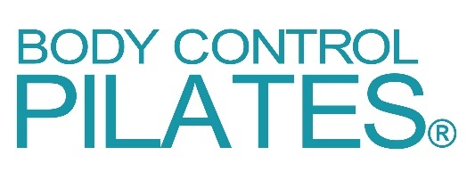

COVID-19 Supplementary Questionnaire
(Form CVSQ)

IMPORTANT NOTE:

This is supplementary to the standard Body Control Pilates Enrolment Form, which must already have been completed.

This form only needs to be completed and submitted before your first visit after reopening.

Your Name:

Current Address:
Home Address (if different):
Email Address:
Mobile Phone Number:
Date of Birth:

IMPORTANT ADVICE

If you have any of the following symptoms or are feeling unwell, please do not come to class:
- Fever; a new and continuous cough; loss of taste or smell

If a member of your household has any of the above symptoms and is waiting for a test, please self-isolate and do not attend class until the results are known.

Please also refrain from coming to class if you have any of the following symptoms and these are new and unexplained:
- shortness of breath; fatigue; loss of appetite; muscles aches and pains; sore throat; headache; nasal congestion; diarrhoea; nausea and vomiting.

If you have you knowingly been in close contact with anyone who has tested positive for Covid-19 in the last 14 days, please do not attend class until 14 days from that contact have elapsed.

Further advice is available from the NHS Coronavirus Service: https://www.nhs.uk/conditions/coronavirus-covid-19 or call 111 for advice.

You and COVID-19

 |  | YES | NO
1 | Have you had, or suspect you have had Covid-19 Coronavirus?
2 | If yes, when?
3 | If yes, was this diagnosed by means of a positive test result?
4 | Have you attended the Emergency Department or been admitted to  hospital due to Covid-19 symptoms?
Note: If you answered ‘Yes’ to Question 4, has your doctor given you
permission to exercise?
5 | Are you still experiencing symptoms post Covid-19?  If yes, please list them:

More about you

 |  | YES | NO
6 | Are you an NHS front line worker?
7 | Are you a carer in a care home?
8 | Are you considered to be at extra risk (i.e. clinically vulnerable)?
9 | Do you have a family member who is vulnerable or extremely vulnerable?
10 | Are you pregnant?  If yes, how many weeks?
11 | Are you allergic to specific cleaning products?  If yes, please give details:

YOUR SIGNATURE

I confirm that the above information is accurate and give consent for my contact details to be given to NHS Test and Trace should this be required.

I have read and understood the ‘Important Advice’ and will contact my teacher about any future change in my circumstances.

Signed:

Dated:

Thank you for providing the above information, which will be stored securely and used in complete confidence.

Please complete this form, save it to your computer, and email it as an attachment to your teacher.

